**KASA INITIATIVE GHANA**

**Activity Report**

**Activity: Capacity Building Workshop for Media and Civil Society Organisations on Climate Change Reporting**

**Convenor: Kasa Initiative Ghana**

**Venue: Miklin Hotel, East Legon, Accra, Ghana**

**Date: 25 October 2024**

**Report Compiled By:**

**Gayson Siampongo**

**Environmental Sustainability & Climate Action Advisor (Volunteer)**

**Report Submitted to:**

**Jonathan Gokah**

**KASA Initiative Ghana Coordinator**

Table of Contents

1.0 Introduction 3

1.1 Welcome Remarks: Kasa Initiative Ghana 3

2.0 Setting the Tone and Proceedings 3

3.0 Observations, causes and impacts of climate change 3

4.0 Vulnerability, Mitigation and Adaptation 4

5.0 Addressing Climate Change in Ghana 4

6.0 Climate Change Policy Frameworks and others in Ghana 5

7.0 Ways to improve climate change reporting 5

8.0 Action Points or Way Forward 7

9.0 Conclusion 7

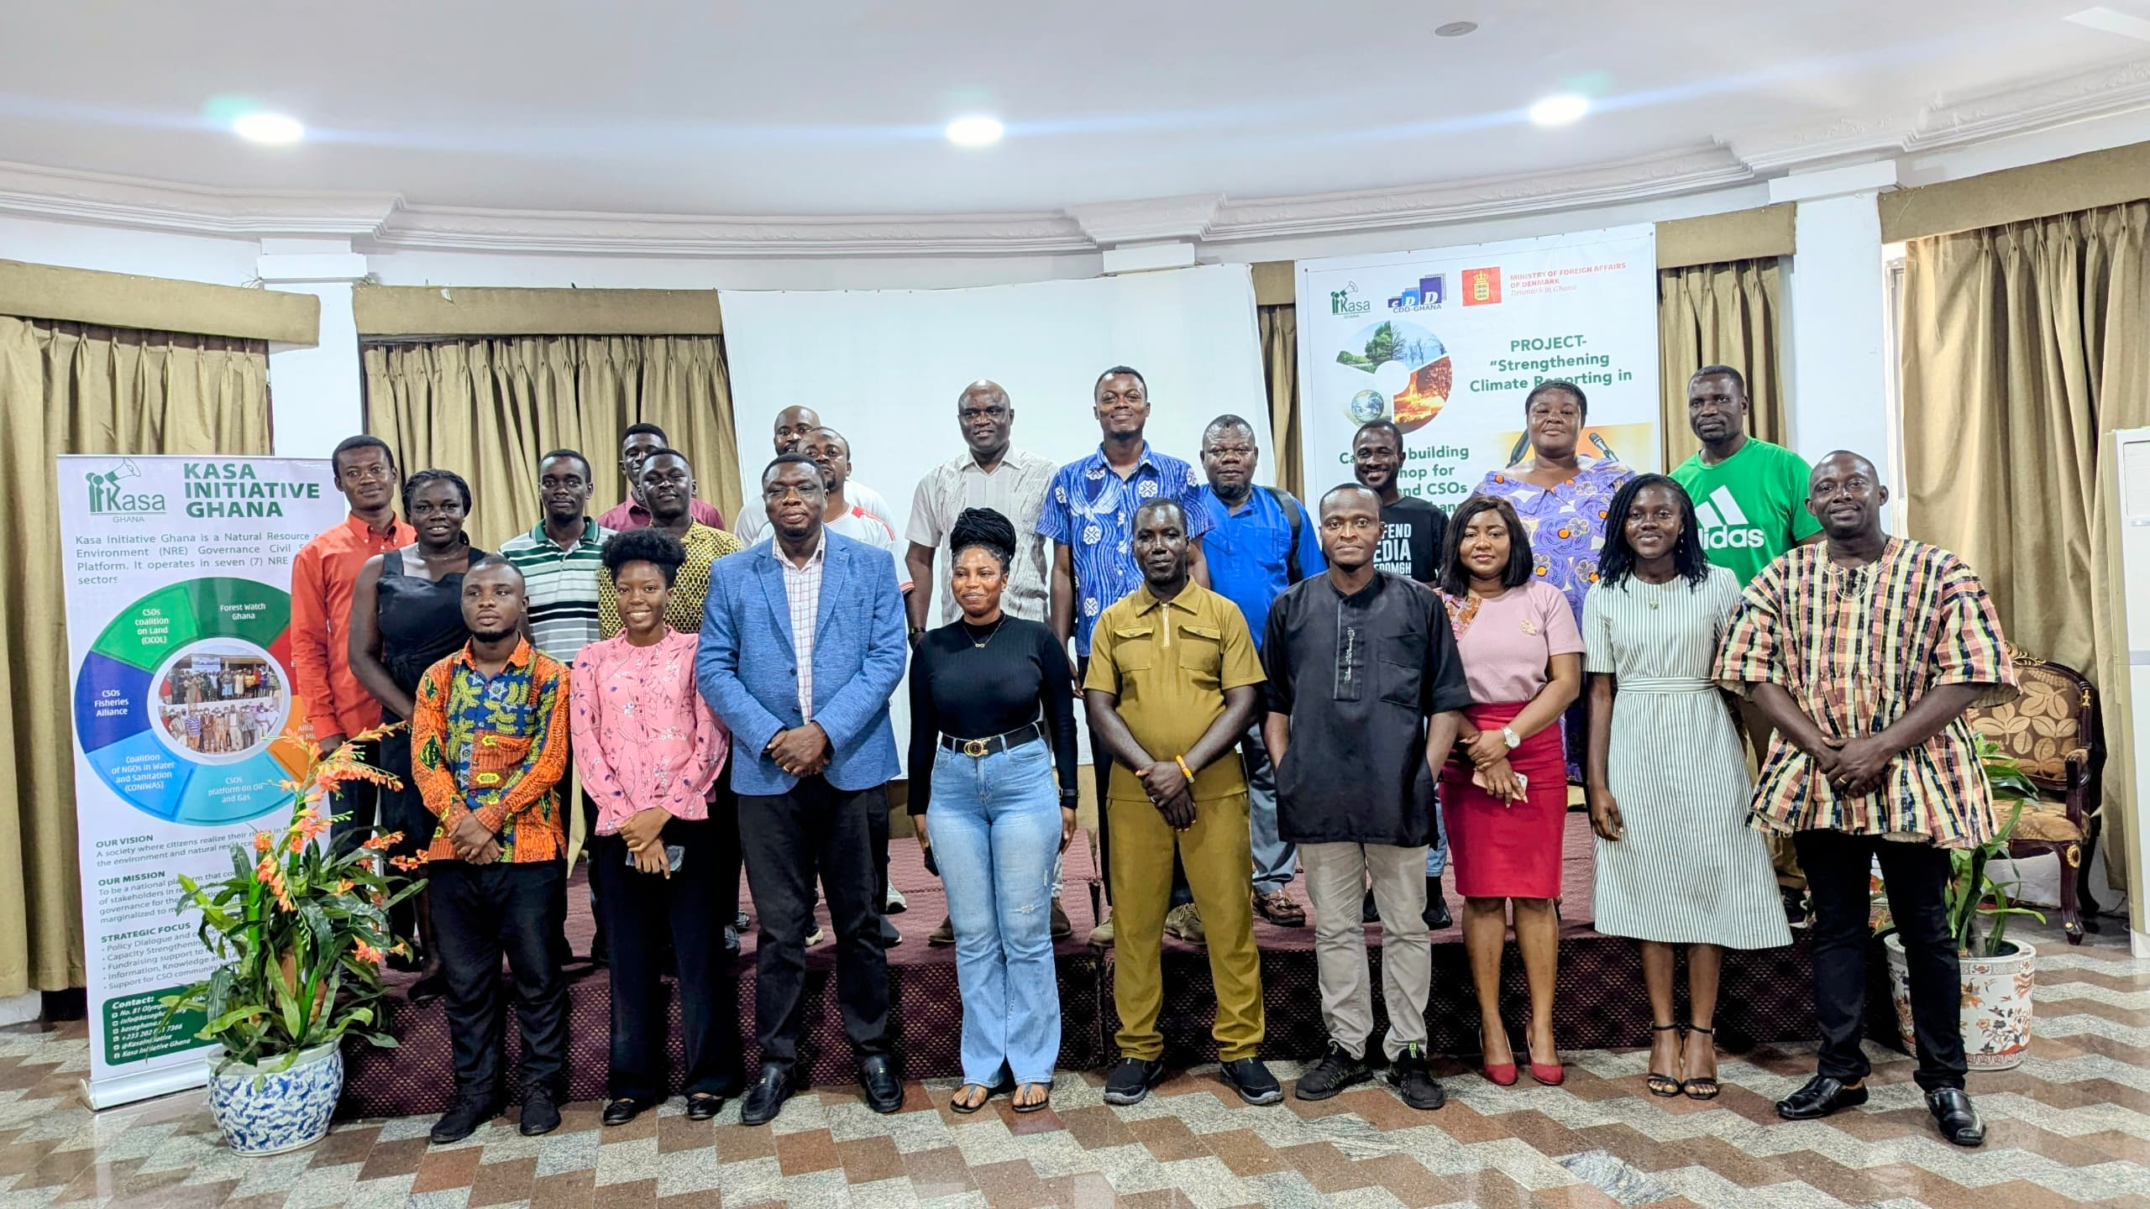

# Introduction

Climate change has brought a lot of devastating challenges to sustainable development hence a lot of efforts have been and are still being applied by different actors to combat and or reduce its impacts. However, timely and accurate reporting with concrete information has and is still a challenge in Ghana and beyond. That being the case, Kasa Initiative Ghana saw it necessary to engage the fourth estate (Media) and like-minded Civil Society Organisations (CSOs) so as to bridge that gap through capacity building on climate change reporting. The activity was held at Miklin Hotel and organised by Kasa Initiative Ghana in partnership with Centre for Democratic Development (CDD), Danish Embassy in Ghana and World University Service of Canada (WUSC).

## Welcome Remarks: Kasa Initiative Ghana

The National Coordinator for Kasa Initiative Ghana Jonathan Gokah broke the ice by giving warm welcome remarks to all the participants and also leading the group into self-introductions. The Coordinator explicitly elaborated that the workshop was about every participant to understand climate change, its causes as well as its impacts and then contextualize that to Ghana. He also challenged participants to analyse and understand the linkage between climate change with various development sectors. Emphasis was put that every report should have a link with climate change hence reporters must always put climate change at the back of their mind and be able to interrogate climate change links or nexus to development sectors. The main idea was put forward that detailed reporting should elaborate more about climate change since it is the devil that the world is confronted with in which every individual must play a part. The main idea is to be able to save the vulnerable and also enhance engagement opportunities with different service providers, duty bearers and or policy makers or agencies for a conducive environment that is good for sustainable development.

# Setting the Tone and Proceedings

Setting the ground was done by the Communications and Publicity Advisor Lilian Mukami through introduction of a pre-assessment tool that every participant was expected to fill in. The tool was generally meant to establish knowledge levels before and at the end of the training while it was also there to capture expectations from every participant and tailor make the training so as to cover all the critical areas. Later on, the button was then handed over to the main facilitator.

# Observations, causes and impacts of climate change

The session started with presentations from the facilitator looking at the causes and impacts of climate change in general and then zeroing down contextualizing the issue to the Ghana situation. It was shared that climate change impacts negatively on weather, environment, agriculture, and human beings, among other critical development areas. Causes and impacts of climate change were unpacked further with pictorial presentations and examples. However, it was also agreed that some of the causes of climate change are human activities hence those can be dealt with as long there is political will, for example, poor land use and or management, widespread deforestation and illegal mining (galamsey). A pictorial presentation was done to highlight how climate change was affecting the environment. Some of the effects highlighted include droughts, soil degradation, pests and diseases, changes in rainfall patterns, reduction in biodiversity and other economic consequences, and all these were unanimously agreed by all the participants.

# Vulnerability, Mitigation and Adaptation

These terms were well simplified and elaborated for every participant to understand. Use of examples made it easier for the participants to follow and understand as well as giving them opportunities to ask questions and or seek clarity in between presentations. The facilitator revealed that vulnerability is a function of exposure, sensitivity and adaptive capacity. Residual risk, loss and damage as well as climate change event were all explained in detail. The facilitator went on to give examples from the galamsey challenges and how it’s affecting the environment. It was also highlighted that the use of chemicals in galamsey processes does not only harm those that use them but also other innocent people. Shocking statistics were also shared that 34 forestry reserves in Ghana have already been affected by galamsey while 60% of water bodies were also affected by the same malpractice. However, participants were challenged to know and analyse the nexus between galamsey and climate change while recommendations were also put across that there is need to invest in more sustainable processes that are good for the environment. Some examples put across include but not limited to cocoa and bamboo farming, tilapia oil production and many other nature based solutions. However, a question was raised on, if there was a way of using technology in mining that has little land degradation. The response was that there was no-way mining can be done without disturbing the environment as reclamation can never be 100% effective.

## Addressing Climate Change in Ghana

There are a number of strategies and or initiatives that can be used to mitigate the impacts of climate change as established from this session. Some of the initiatives presented as possible solutions to addressing climate change challenges in Ghana include the following:

* Climate proofing development
* Emission levy and Cap-and –Trade System
* Gender Inclusive Climate resilience programs
* Proper mining and land use management
* Climate insurance
* Climate education
* Legislation framework
* Environmental restoration
* Infrastructural development code

**NB:** The day also went on with information sharing on the policies and instruments to drive the mitigation agenda in addition to challenges slowing down climate change efforts.

# Climate Change Policy Frameworks and others in Ghana

Different climate policy frameworks were shared through a presentation from the facilitator clearly highlighting their main objectives and their contributions to climate change advocacy. Key institutions addressing and or responsible for addressing climate change in Ghana were shared by the facilitator and encouraged reporters to know them and probably interact and have links with them for improved reporting. However, on climate change policies, the following were shared:

* The National Climate Change Adaptation Strategy (NCCAS 2012)
* The National Climate Change Policy (NCCP 2013)
* The Nationally Determined Contribution Framework (NDC 2015)
* Climate Risk Profile Ghana (2021) – according to the World Bank
* Government of Ghana (2021) – Ghana’s Adaptation Communication to the United Nations Framework Convention on Climate Change
* Ghana’s National Energy Transition Framework (2022-2070)

# Ways to improve climate change reporting

The session was done through group works and later some presentations from each of the three established groups. The group suggestions were also taken as part of some action points to be considered going forward so as to improve on climate change reporting and be able to make sure that vulnerable communities get necessary, relevant, timely and well-packaged information on climate change. On the same note, it was also to establish areas of engagement with relevant stakeholders for policy enactment and implementation towards a conducive environment in which journalists can be able to report without fear or favour.

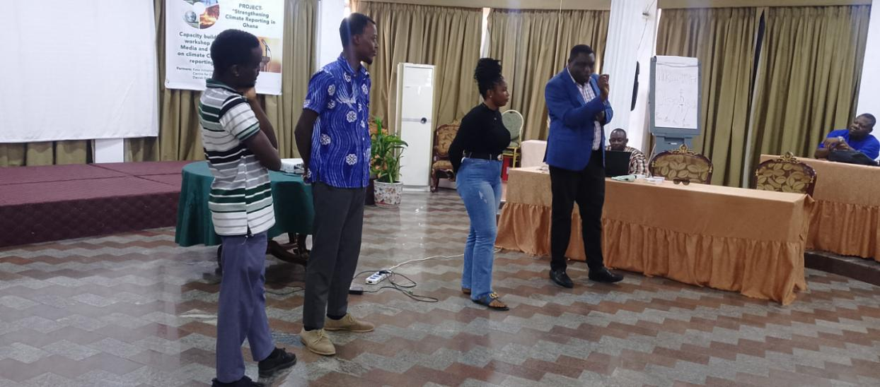

Figure 1: Individual group presenters flanked by Jonathan Gokah the National Coordinator Kasa Initiative Ghana

The following were some of the suggested ways on how climate change reporting can be improved according to reporters:

**Group One**

* Assessment and access of available data on climate change
* Media workshops or training on climate change
* Collaboration with climate change experts and or stakeholders
* Community engagements with locals
* To have media policies and guides on climate change reporting
* Enhancing social media platforms

**Group 2**

* Capacity building of media personnel on climate change
* Collaboration between stakeholders and media so as to get more relevant information from the on climate change.
* Commitment on the part of media owners to dedicate a space for climate change issues
* Inclusion or involvement of climate change experts in climate change processes
* Conduct regular follow-ups and feedback on critical issues

**Group 3**

* Forming an environmental desk in the news room
* Get reporters to specialize on environmental issues
* Collaborate with CSOs, EPA, Ministry of Environment, Science, Technology and Innovation, and the Forestry Commission, among other agencies
* Organize content training for reporters,
* Recognize international environmental and earth days and create contents, workshops, quizzes and other ambitious climate change actions
* Give motivational quotes on climate change during news casting or programs
* Media house should organize community engagements to educate the local people on climate issue as a part of media houses corporate information
* Appreciation of policies and creation of content on climate change – make jingles and or adverts

**NB:** However, it was revealed that mostly there was lots of investments in climate change but reporting was still very minimal. That then led to cementing that capacity building of media personnel was a way to go for reporters to report form informed positions. Some statistics on different amounts received by the Government of Ghana to address climate change were shared. It was unfortunate that, a few or no reporter had the information which also revealed existing gaps in reporting as transparency and accountability issues remain emphasized.

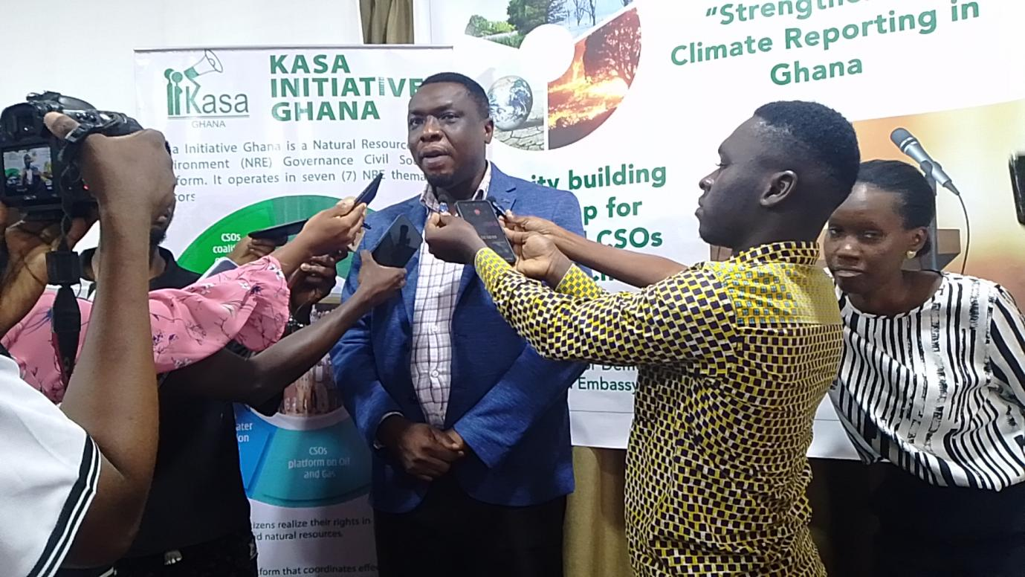

Figure 1: Kasa Initiative Ghana National Coordinator Jonathan Gokah unpacking the training objectives as every reporter takes interest in capturing every word and action from the training

# Action Points or Way Forward

A few issues were agreed as action points from the workshop and those were as follows:

* To create a WhatsApp platform for continued information sharing
* To organise some activities where reporters can meet and then physically visit galamsey sites so as to have an appreciation of its impacts to the environment
* Sharing of presentations
* To core-create some stories as media houses
* Reporters to write their stories on the just ended capacity building workshop and share them through the created WhatsApp platform

# Conclusion

The workshop was conducted in a participatory way in which every participant was given opportunity to contribute. Sharing of practical experiences on what was happening on the ground looking at the causes and impacts of climate change facilitated the whole subject to be very much engaging and understandable. All reporters appreciated the activity and recommended that there was really need for more of such activities in future for informed reporting and be able to relay relevant and well researched information at the right time.